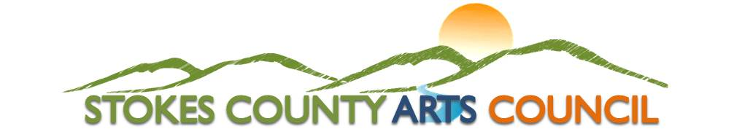

P.O. Box 66 / 500 Main St. / Danbury, NC 27016 / 336 593-8159 / [www.StokesArts.org](http://www.StokesArts.org)

**The Stokes County Arts Council is planning a celebration on Sunday, March 2nd from**

**2-4pm at The Arts Place of Stokes in Danbury, NC. This celebration will honor Gypsy Hollingsworth and will introduce a fiber arts program and grant named in her honor.**

**We are gathering memories to share at our upcoming event and to archive for future generations. If you have any art pieces that we could display or photographs that we could copy, please let us know. These would be most welcome.**

**For more information about our upcoming event, please visit** [**www.stokesarts.org**](http://www.stokesarts.org)**, call (336) 593-8159, or email Janeise Harmon at janeiseharmon@gmail.com**

Name:

Email Address:

Phone Number:

What is your association with Gypsy?

Please share your story or anecdotes of times you spent with Gypsy or of the impact she had on your life:

Memory 1:

Memory 2: