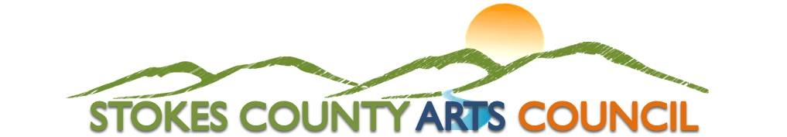
P.O. Box 66 / Danbury, NC 27016 / 336 593-8159 / www.StokesArts.org

2023 Stokes County Arts Council Scholarship Application
Please type or print in black ink. Incomplete applications will not be considered.
Reminder that this application including all letters of reference, school transcripts, and additional requested information is due to The Stokes County Arts Council by 5:00 P.M. on Friday, March 17, 2023. Items that are only postmarked by March 17th will not be accepted.

Name___________________________________________________ Date of Birth __________________
First M.I. Last
Address_______________________________________________________________________________
Street Apt. City State Zip
Social Security Number_______-______-_______ Phone No.__________________________________
(Choice of Applicant)
Name of Father ______________________________ Occupation ________________________________
First Last
Name of Mother _____________________________ Occupation ________________________________
First Last
Number of Brothers and Sisters____________________________________________ Ages___________

Your intended major _____________________________________________________________________

Proposed career plans____________________________________________________________________

List high schools, colleges and date(s) attended _______________________________________________________

Honors, awards, clubs, offices held, etc. [Use additional sheet(s) if necessary] _______________________

_____________________________________________________________________________________

School Activities [Use additional sheet(s) if necessary] __________________________________________

______________________________________________________________________________________

Community Activities [Use additional sheet(s) if necessary] ______________________________________

______________________________________________________________________________________

Overall academic average or GPA _______ Class Rank _________________________________

Have you been accepted by a College/University?______________________ Student Pin No. __________

If yes, where?___________________________________________________________________________
Name of Institution City State

Other scholarships for which you have applied_________________________________________________

Other scholarships received________________________________________________________________

Are you employed during the school year?___________ Where?________________________________

Total gross income of parents/guardians______________________________________________________

Page 2

Please provide the following:

(Note: This list of items is required for a complete application to be considered by the Review Committee.)

- A copy of your high school transcript/college transcript.
- Three letters of reference. At least one letter should be included from an educator who has taught you in your field of interest. All recommendation letters should be on letterhead (if available) and in a sealed envelope. No recommendation letters will be accepted via e-mail/electronic methods.
- Please provide with your application at least three representative samples of your work. This may be in the form of original work, clear photographs, video, CD, and audiotape, etc.
- Please include a brief statement (approximately 250-500 words) explaining the way in which the arts have impacted your life.
- Please feel free to include any other information that you feel would help the committee in their selection.
- An interview with the committee may be required.

Endorsement of Parent or Guardian:

I, ___________________________________________(please specify parent/guardian) of the above applicant, hereby declare that, to the best of my knowledge, the foregoing statements are complete and correct. I approve the applicant’s application for a scholarship.

X___________________________________________ X________________________________
Signature of parent or guardian Date

Applicant’s Statement:

I, ___________________________________________, hereby declare that, to the best of my knowledge, the foregoing statements are correct.

X_____________________________________________ X_________________________________
Applicant Signature Date

Application is complete based on requirements outlined to be submitted by applicant. Please be sure to review all documents and include all attachments as required and sign all documents attached where signature is required.

Mail To: Stokes County Arts Council, P.O. Box 66, Danbury, NC 27016
Deliver: Stokes County Arts Council, 500 Main Street, Danbury, NC 27016

FOR SCAC USE ONLY

DATE RECEIVED_____________________________

TIME RECEIVED_____________________________

