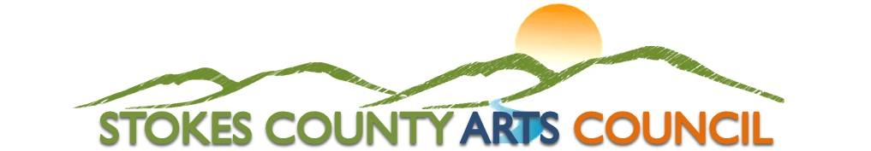
500 N. Main Street (P.O. Box 66) Danbury, NC 27016, (336) 593-8159
www.stokesarts.org

2023 #yesYOUcan Scholarship in honor of Lynne Oakley

The #yesYOUcan scholarship was created by Tara Schiphof and Melanie Oakley in honor of their mother and grandmother Lynne Oakley in an effort to help the next generation persevere through life’s greatest challenges

Please type or print in black ink. Incomplete applications will not be considered. Reminder that this application including all letters of reference, school transcripts, and additional requested information is due to The Stokes County Arts Council by 5:00 P.M. on Friday, March 17, 2023

Items that are only postmarked by March 17th will not be accepted.

Name___________________________________________________ Date of Birth __________________
First M.I. Last
Address_______________________________________________________________________________
Street Apt. City State Zip
Phone No.__________________________________

Name of Father ______________________________ Occupation ________________________________
First Last
Name of Mother _____________________________ Occupation ________________________________
First Last

Your intended major _____________________________________________________________________

Proposed career plans____________________________________________________________________

List high schools, colleges and date(s) attended _______________________________________________________

Honors, awards, clubs, offices held, etc. [Use additional sheet(s) if necessary] _______________________

_____________________________________________________________________________________

Activities in school or community [Use additional sheet(s) if necessary] ____________________________

Describe or list any Volunteer Work within the community
____________________________________________________________________________________

Overall academic average or GPA _______ Class Rank _________________________________

Have you been accepted by or already attend a College/University?_____________ Student Pin No. __________________

If yes, where?___________________________________________________________________________
Name of Institution Address/City State/Zip Code

Other scholarships for which you have applied_________________________________________________

Other scholarships received________________________________________________________________

Are you employed during the school year?___________ Where?________________________________

Please provide the following:

(Note: This list of items is required for a complete application to be considered by the Review Committee.)

- A copy of your high school transcript/college transcript.
- Three letters of reference. At least one letter should be included from an educator who has taught you in your field of interest.
- Please include a brief statement (approximately 250-500 words) describing a time that you have persevered in your life.
- Please feel free to include any other information that you feel would help the committee in their selection.
- An interview with the committee may be required.

Endorsement of Parent or Guardian:

I, ___________________________________________(please specify parent/guardian) of the above applicant, hereby declare that, to the best of my knowledge, the foregoing statements are complete and correct. I approve the applicant’s application for a scholarship.

X___________________________________________ X________________________________
Signature of parent or guardian Date

Applicant’s Statement:

I, ___________________________________________, hereby declare that, to the best of my knowledge, the foregoing statements are correct.

X_____________________________________________ X_________________________________
Applicant Signature Date

Application is complete based on requirements outlined to be submitted by applicant. Please be sure to review all documents and include all attachments as required and sign all documents attached where signature is required.

U.S. Mail: Stokes County Arts Council, P.O. Box 66, Danbury, NC 27016
Deliver: Stokes County Arts Council, 500 Main Street, Danbury, NC 27016

Applicant Criteria

Must have been accepted or currently enrolled in a community college or private/public four-year college or university

